**Variables in JavaScript**

**What is a Variable?**

A variable is a container for storing data values. In JavaScript, you can declare variables using:

* var
* let
* const

**Declaring Variables**

**Syntax :**

**var variableName; // Using var**

**let variableName; // Using let**

**const variableName = value; // Using const with initialization**

**Rules for Naming Variables:**

* Must start with a letter, $, or _.
* Cannot start with a number.
* Cannot use reserved keywords (e.g., if, else, let).

**Types of Variables**

**1. Using var**

* Older way to declare variables.
* Function-scoped.
* Can be re-declared and updated.

**2. Using let**

* Modern way to declare variables.
* Block-scoped.
* Cannot be re-declared in the same scope but can be updated.

**3. Using const**

* Modern way to declare constants.
* Block-scoped.
* Must be initialized at the time of declaration and cannot be updated.

**Example Programs**

**1) Using var**

**function exampleVar() {**

**var x = 10;**

**console.log("Value of x initially:", x); // Output: 10**

**if (true) {**

**var x = 20; // Same variable (function-scoped)**

**console.log("Value of x inside block:", x); // Output: 20**

**}**

**console.log("Value of x outside block:", x); // Output: 20**

**}**

**exampleVar();**

**2) Using let**

**function exampleLet() {**

**let y = 10;**

**console.log("Value of y initially:", y); // Output: 10**

**if (true) {**

**let y = 20; // Block-scoped variable**

**console.log("Value of y inside block:", y); // Output: 20**

**}**

**console.log("Value of y outside block:", y); // Output: 10**

**}**

**exampleLet();**

**3) using const**

**function exampleConst() {**

**const z = 30;**

**console.log("Initial value of z:", z); // Output: 30**

**// z = 40; // TypeError: Assignment to constant variable**

**if (true) {**

**const z = 50; // New block-scoped variable**

**console.log("Value of z inside block:", z); // Output: 50**

**}**

**console.log("Value of z outside block:", z); // Output: 30**

**}**

**exampleConst();**

**4. Program Showing the Difference Between var, let, and const**

**function compareVariables() {**

**// Using var**

**var a = 5;**

**var a = 10; // Allowed**

**console.log("var a:", a); // Output: 10**

**// Using let**

**let b = 15;**

**// let b = 20; // SyntaxError: Cannot re-declare variable**

**b = 20; // Allowed**

**console.log("let b:", b); // Output: 20**

**// Using const**

**const c = 25;**

**// c = 30; // TypeError: Assignment to constant variable**

**console.log("const c:", c); // Output: 25**

**if (true) {**

**var a = 50; // Same variable**

**let b = 60; // New block-scoped variable**

**const c = 70; // New block-scoped constant**

**console.log("Inside block - var a:", a); // Output: 50**

**console.log("Inside block - let b:", b); // Output: 60**

**console.log("Inside block - const c:", c); // Output: 70**

**}**

**console.log("Outside block - var a:", a); // Output: 50**

**console.log("Outside block - let b:", b); // Output: 20**

**console.log("Outside block - const c:", c); // Output: 25**

**}**

**compareVariables();**

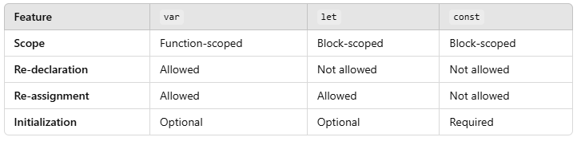

**Best Practices**

1. Use let for variables that may need to change.
2. Use const for constants or variables that should not be reassigned.
3. Avoid var in modern JavaScript.